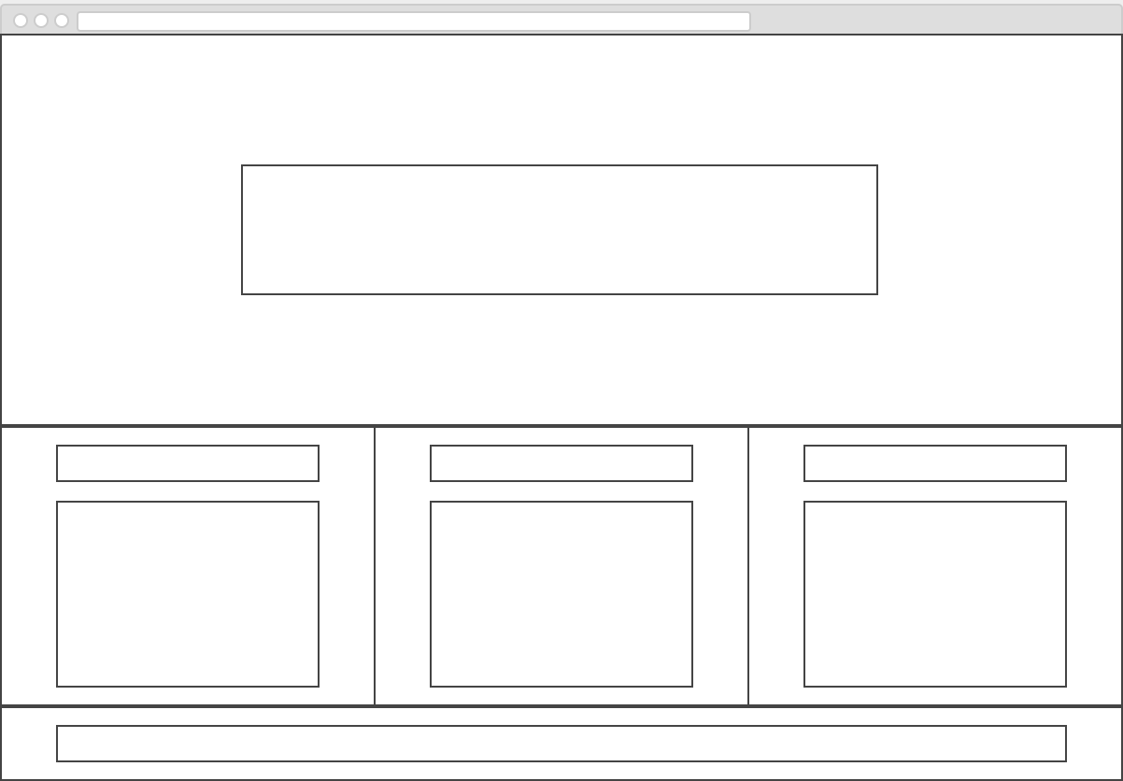

FOOTER

ASIDE

ARTICLE

ARTICLE

HEADER